**Designing a travel planning app**

**- a design coursework**

By Anh hoang

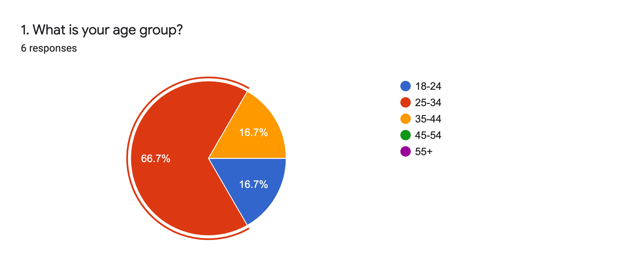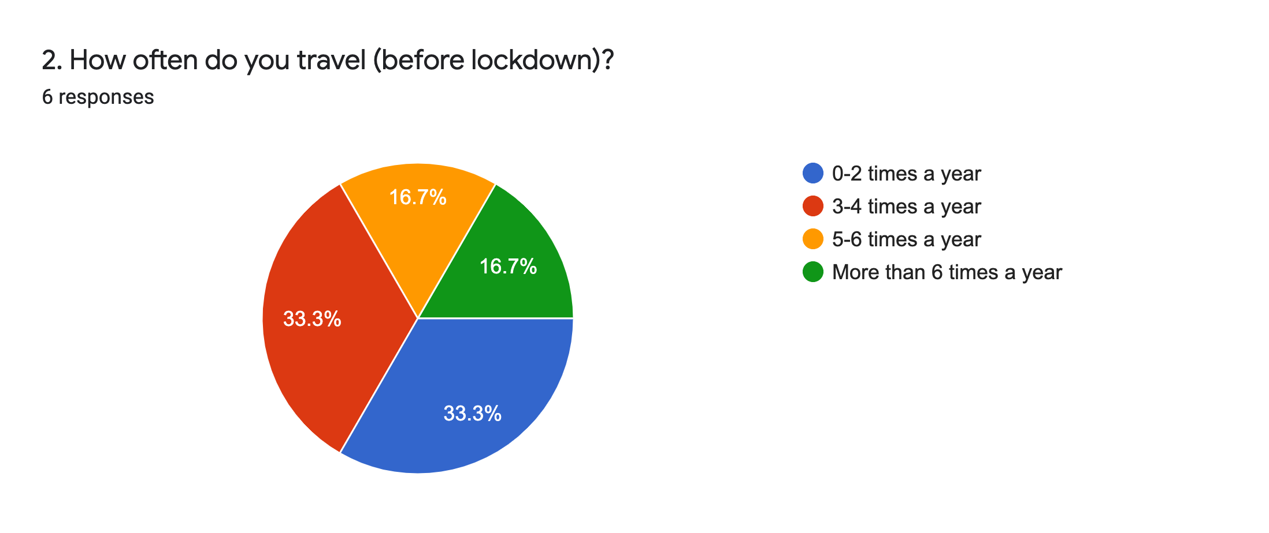**Quantitative date collected from survey**

Participants varied in age which predicted the trends in planning holidays/ trips.

The targeted age group (25-34) on average, travel 3-4 times a year

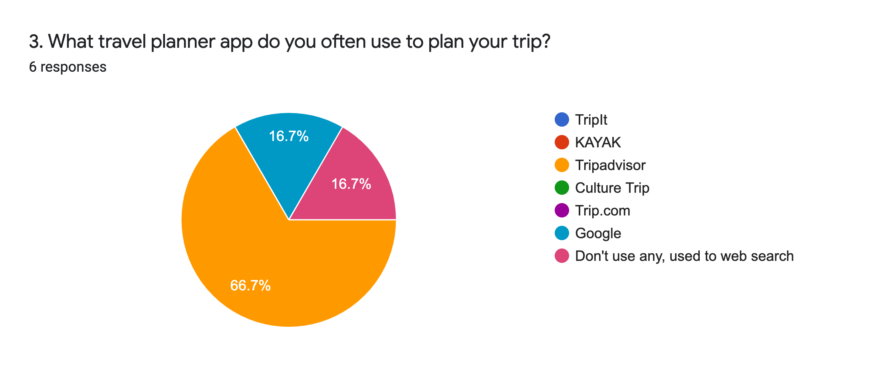

Some specialised trip planning apps are unfamiliar with participants, except TripAdvisor.

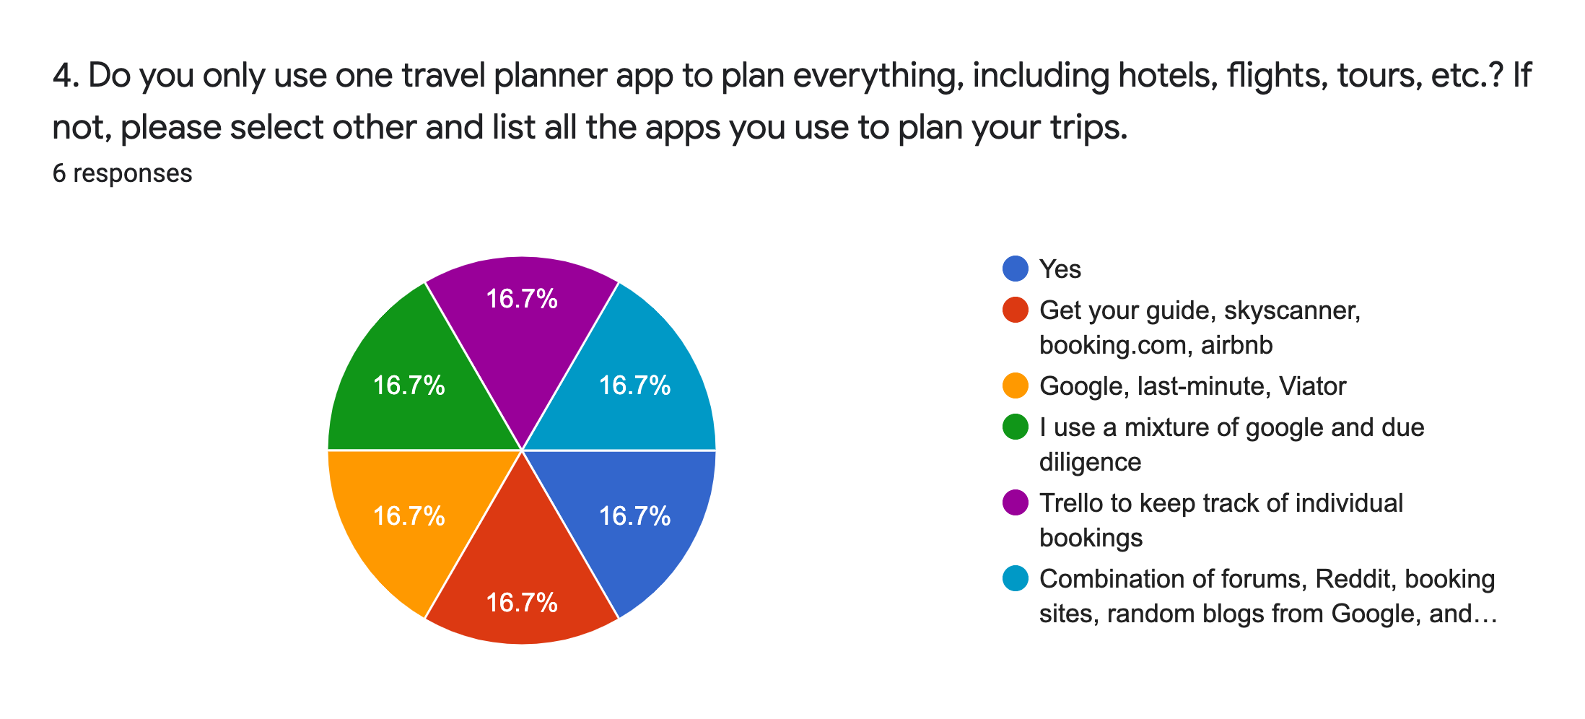

Participants tend to search for their trips on different websites and forums than planning their trips on a specialised trip planning app.

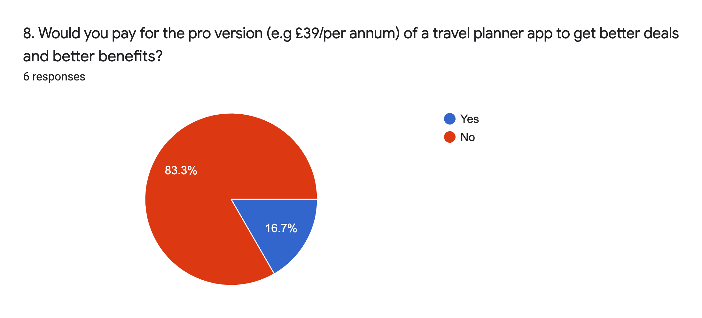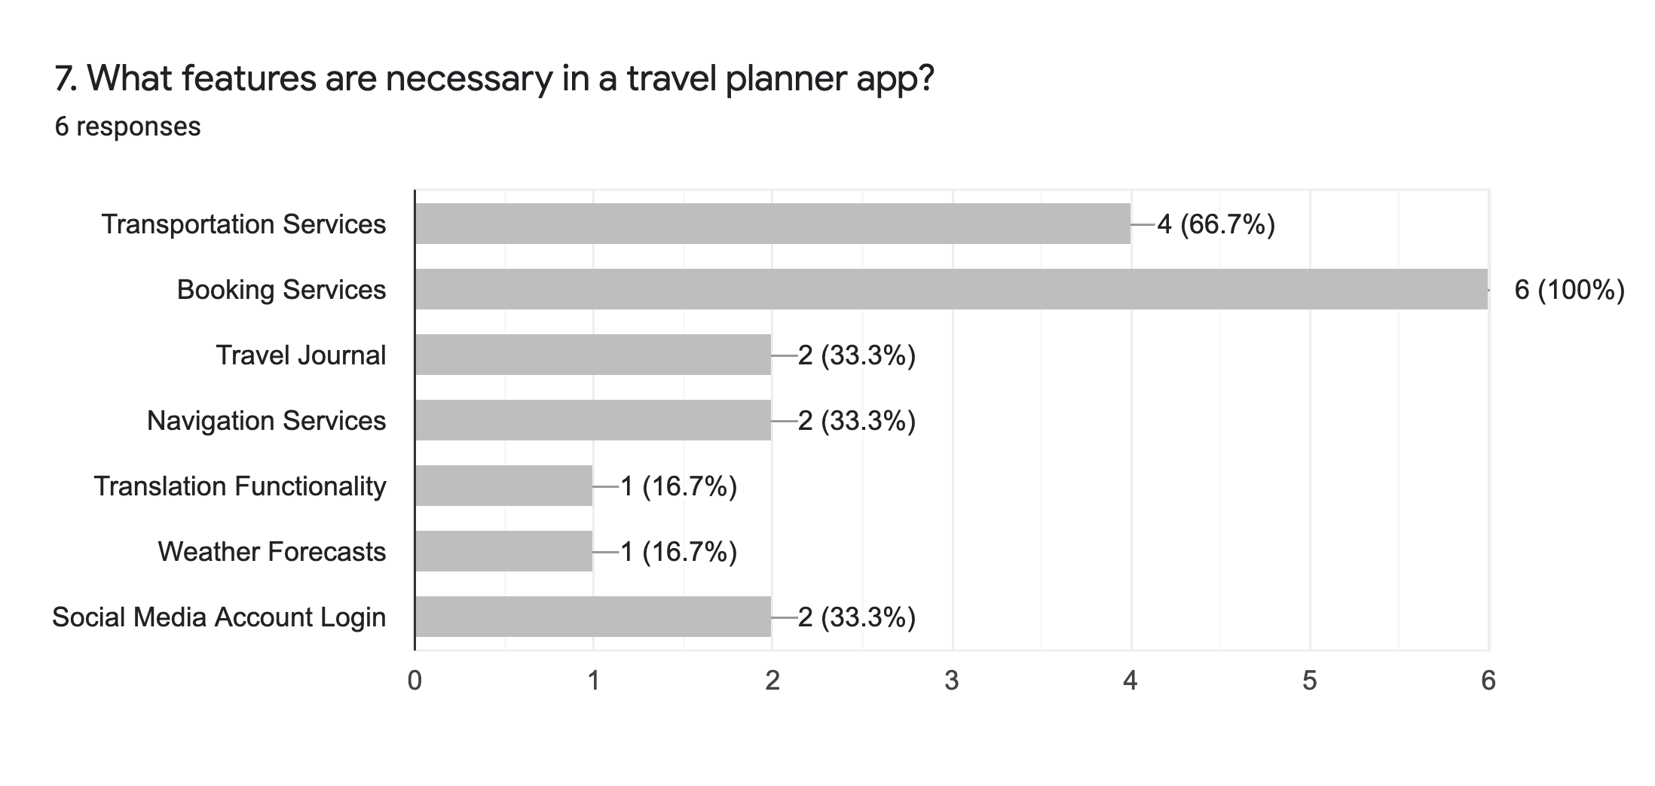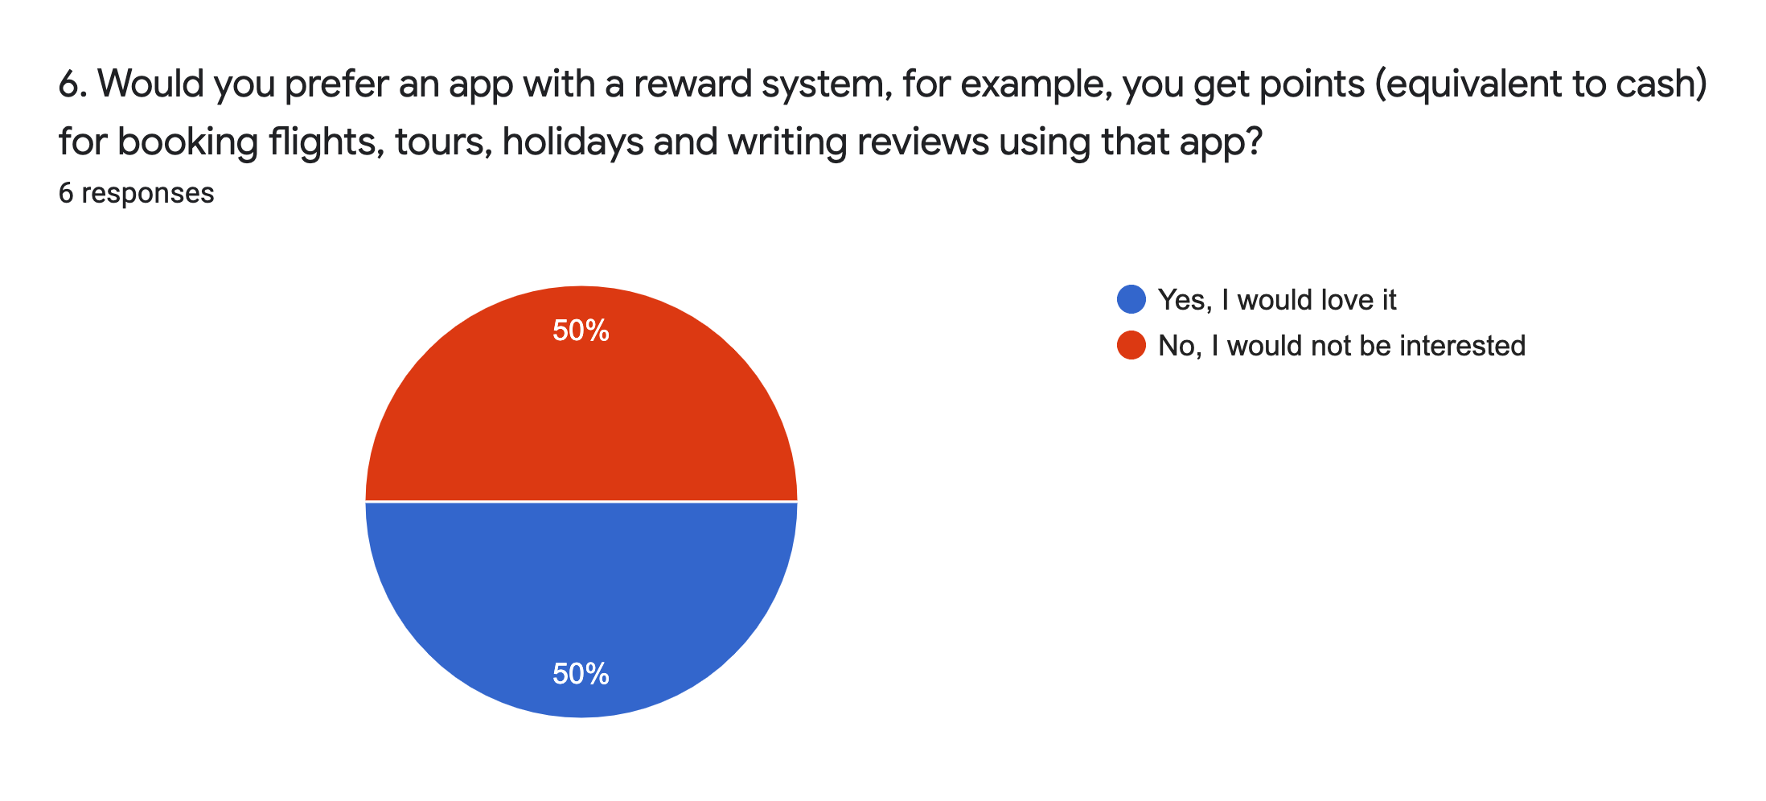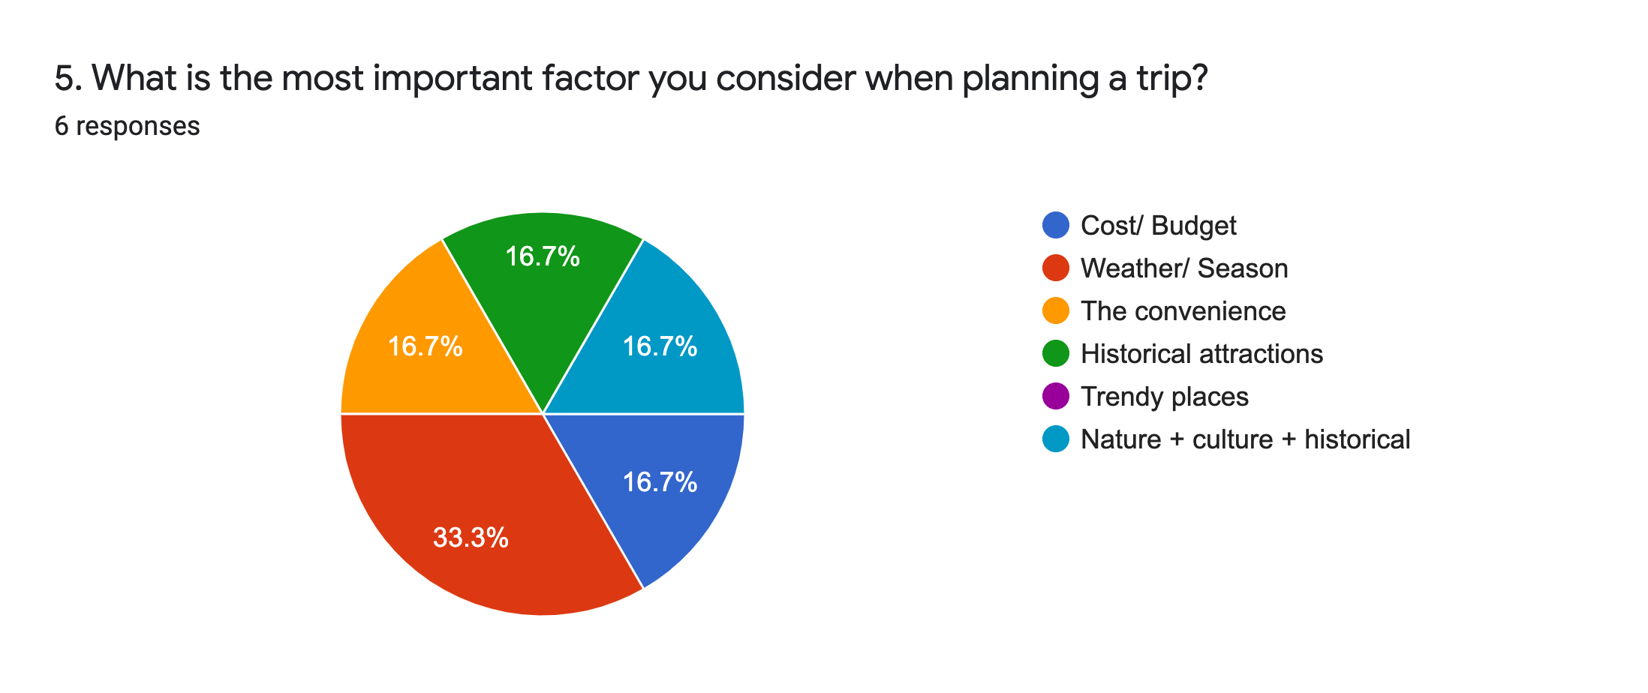

A pro version is not preferred, participants prefer a free app with

useful features

Booking Services and Transportation Services are required features for a travel planner app

Weather/ Season are important factors for participants when planning their trips. A reward system is not preferred.

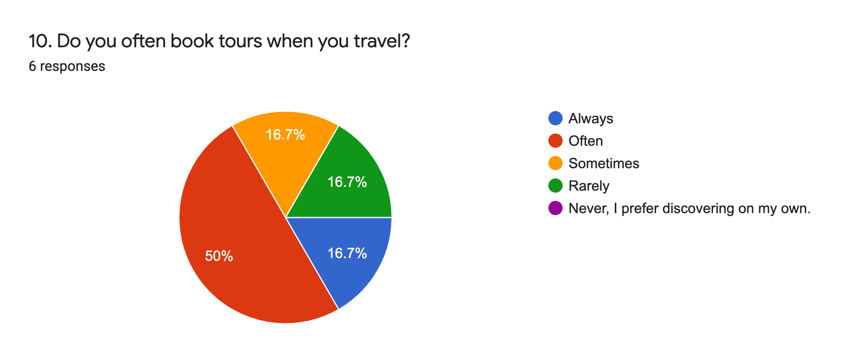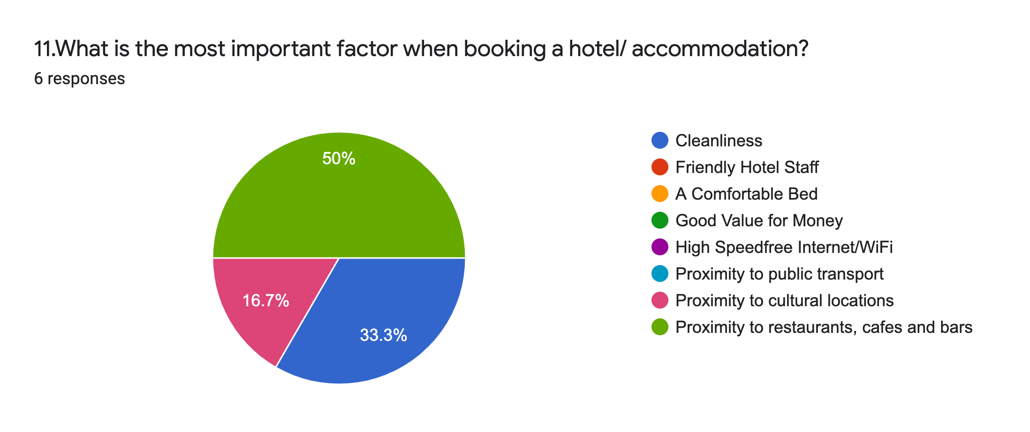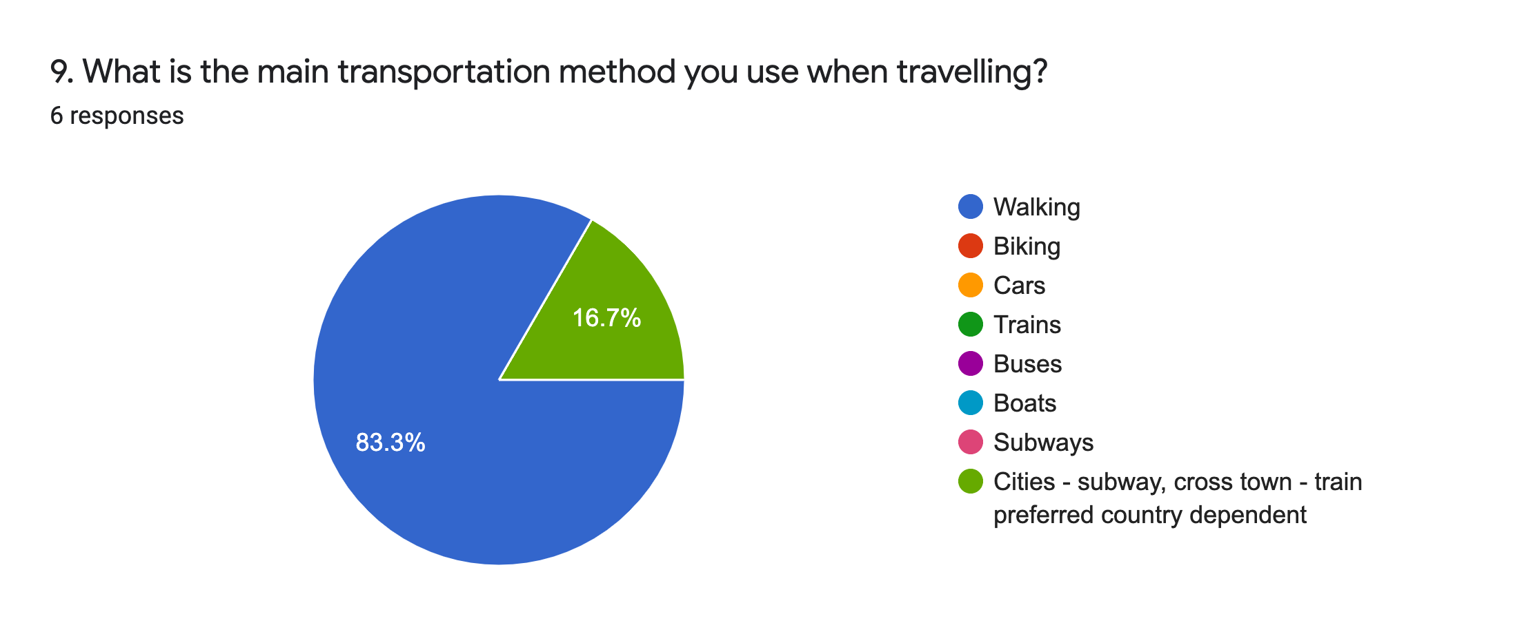

50% often book tours, showing the importance of tour guides for travellers. This suggests a trend and demand in tours, to help travellers save time when planning their trips.

The majority of participants picked walking as the main transportation method. This means that car hire feature is not needed in a travel planning app.

2. Define

|  |  |
| --- | --- |
| **Feature** | **Description** |

**Must Have**

**Nice To Have**

**Can Come Later**

* Users could make payments for their bookings directly from the app
* Calculator that allow users to convert any currency to country they are visiting
* An online, available 24/7 bot to provide general help with features of the app
* More languages available for easily accessible
* A program allowing users to plan their trips step by step, from selecting multiples destinations to flights to hotels, etc.
* Make changes, add destinations to booking details
* Create, edit and update personal information
* Users personal information, such as name, email, address, phone number
* Reviews from other users including information about their previous trips, tips and travel advice
* Allow users to keep a journal to cover the entirety of their trip, e.g. pictures, diary
* Guide for users to protect themselves when travel during the pandemic
* Information about a destination, including attractions, accommodation, activities, etc.
* Users would be able to locate train stations, bus stations, and forms of public transportations with ease
* Users can seek to them asking for help if needed
* Provide locations of local hospitals and police stations

* Integrate users social media accounts directly into the app to speed up registration time
* An option for users with additional needs
* Grant users the ability to plan ahead without having to utilise separate apps
* Travellers can feel free to move about without the fear of a language barrier from signs, street maps, or locals

**Payments**

**Currency Converter**

**Chatbot**

**Different Languages**

**Transportation Services**

**Virtual Assistant**

**Local Emergency Services**

**Social Media Account**

**Car Hire**

**Weather Forecasts**

**Translation Functionality**

**Trip Planning**

**Manage Bookings**

**Login/ Signup**

**Account Profile**

**Reviews**

**Travel Journal**

**Safety Guides**

**Travel Guides**

3.

# Testing Feedback

* A total of 10 people completed the usability test.
* A range of different people were asked, including students, a product manager who works a company managing a software product, a backend developer, a few front-end UI developers.
* All of the tests are conducted online by passing the InvisionApp preview link to the test participants.
* Initially, the participants were told to play around with the app with little to no direction. Afterwards, they were given the Test goals to accomplish the specific tasks.
* They were told to provide criticism, both positive and negative of their experience when using the app.

## Key findings

### Positives

* The navigation was initiative for all users, with them easily able to follow through the app with minimal guidance. – “The UX is great” one participant wrote.
* Most people loved the multi destination feature as this is a USP for my app. It is not common for other apps to have this feature.
* People wanted more of a focus on COVID during travel.
* People liked the ‘Start Planning’ user flow of the app. It was hand-holding the user while they did the planning process, which helped them through the booking.

### Criticism

* The app UI was inconsistent, with inconsistent spacing, styles, fonts and colours.
* One participant was drunk at the time of testing and found the app unusable.
* The user flow was sometimes unclear. A few participants noted that after they selected the destination, they abruptly went into the flight booking page, without any detail of the destination, or a confirmation.
* Needs more of a focus on COVID (explained in the feature recommendations below)
* Needs more modes of transport, e.g. trains.

### Feature Recommendations

* A budgeting system to allow users to specify a budget range, then filter recommendations based on that.
* After selecting an initial destination, have the app recommend related destinations to go after that one. For example, travelling to Japan would be a good suggestion after travelling South Korea.
* Ways to monetise the application by providing sponsored Hotels and Things to do. Third parties can pay for their recommendations to show up to users first, which will increase the likelihood users selecting them, bolstering their sales.
* Map feature to overlay destinations on top of. Similar to the hotel map feature.
* An interactive globe, which shows how other users are planning their trip, and an animation of how you would travel when planning - A social media element to the app.
* COVID health features such as (I quote) “a feature to clearly highlights the areas in which you are most likely to die”. Another way to keep users safe is to provide government red lists, depending on their region/government.
* An option to Live Chat to a real human travel agent. This will provide the human touch and connectivity for users to make their process smooth and more interactive.
* A seasoned developer suggested that the app can go in two different directions. If the app is designed to interact with 3rd party flight/hotel services, then there should be very tight integrations to the 3rd parties and payments to make the booking process smooth (no need to context switch between different apps and web pages). If the app has more of a focus on recommending places, then I should focus on advanced search and Machine Learning features, so that the user can find nice places that they would like, simply by using the app.